**AUTOMATIC WATER LEVEL INDICATOR**

*Kumari Kriti Singh1, Aditi Kumari2, Vismaya Ks3, Prachi Sonu4, Krishan Kumar5*

*Student 1234, School of Computer Science and Engineering, Lovely Professional University, Punjab, India*

*Proffesor5, School of Computer Science and Engineering, Lovely Professional University, Punjab, India*

**Abstract**- *This Project mainly aims at optimizing the use of water. Since water wastage has become a major and global issue now, hence water conservation has now become more important. One of the common sources of wastage we encounter is the overflow of water. This project aims to help judge the water level inside the water tank and display it accordingly on the screen while also preventing any overflow of water which is achieved through the Arduino Uno. The ultrasonic sensors used helps determine the water level in tank which is then send to the*  *Arduino Uno, the LED then attached to it displays the level to us. According to the level of water inside the tank, the Arduino helps turn ON or OFF the servo motor hence closing the source of water. In this way, through the automation of water control, we intent to save the energy and our natural resource.***Keywords:***Automatic, Sensor, Save water, Buzzer, Controller* **I. INTRODUCTION**An automatic water level indicator is a vital device that utilizes sensors like ultrasonics or float switches to monitor water levels in tanks.

Integrated with a microcontroller such as Arduino, it processes sensor data and communicates the water level through LEDs, an LCD screen, or remote devices. This system ensures

efficient water management, preventing overflow and enabling timely actions. Often equipped with alarms, it alerts users to critical water

levels, fostering resource conservation and avoiding potential damage. Automatic water level indicators find applications in domestic, industrial, and agricultural settings, contributing to sustainable water usage and environmental responsibility.

It is a smart and efficient system designed to monitor and alert users about water levels in tanks or reservoirs. In response to the global water crisis, this innovative project aims to conserve water resources by preventing overflows and ensuring optimal usage. Powered by Arduino, a versatile microcontroller, the system employs ultrasonic sensors to accurately measure the water levels. These sensors utilize sound waves to calculate the distance between the sensor and the water surface, providing real-time data. The Arduino processes this information and triggers an alarm when the water level exceeds or falls below predefined thresholds. The system's user-friendly design allows for easy customization of alarm settings, enabling users to adapt the indicator to specific needs. Additionally, the Arduino's compatibility with various communication modules facilitates remote monitoring through smartphones or other devices. The project promotes sustainability by preventing water wastage and potential damage caused by overflow. Its affordability and simplicity make it an ideal solution for both residential and commercial applications, offering a practical means to address water scarcity challenges. This Automatic Water Level Indicator with Alarm using Arduino exemplifies the integration of technology for a more resource-efficient and environmentally conscious future.

**II. LITRATURE REVIEW**

# [1] INTERNATIONAL JOURNAL OF RESEARCH CONSTRUCTION OF DIGITAL WATER LEVEL INDICATOR AND AUTOMATIC PUMP CONTROLLING SYSTEM

# Md.Sourove Akther Momin, Pratik Roy

# In modern technology is largely depends on automation and control system. Automation and control system refers the use of various control systems for operating equipment such as machinery, processes in factories, boilers and heat-treating ovens, switching on telephone networks, steering and stabilization of ships, aircraft, automobile and other applications with minimal or reduced human intervention. The greatest advantage of automation and control system is that it saves labor. A water level indicator system is a device that indicates the level of water in a tank or reservoir. It is widely used in industrial applications such as boilers in nuclear power plants and residential applications. The project is to design water level indicator with automatic water pump controlling system. water level sensor has been made for apprehended water level properly. Microcontroller is plighted to restrain the overall system accurately that reduces the control complexity. It takes input through the sensor unit that senses the water level. After taking input, output intends the pump's action (on/off) with respect to current water status of the tank. A display unit indicates the status of pump and water level. The device also monitors the state of level of water whether it is stable, increasing or decreasing with what velocity. It also stores the total time of pump being kept ON. It also keeps monitoring whether the pumping is working well or not. While keeping the motor ON it detects whether the motor pump is working well or not every minutes. If the level is increasing or decreasing in each minute then the indicator shows the motor pump is working well else after three minutes if the level remains stable then it shows there is a problem in motor. Thus, it also monitors the working performance of the pump.

# [2] AN AUTOMATIC WATER LEVEL INDICATOR

# Aranyak Roy, Oyndrila Roy

# The drinking water crisis in Asia is reaching alarming proportions. It might very soon attain the nature of global crisis. Hence, it is of utmost importance to preserve water for human beings. In many houses there is unnecessary wastage of water due to overflow in overhead tanks. Automatic Water Level Indicator and Controller can provide a solution to this problem. The operation of water level controller works upon the fact that water conducts electricity due to the presence of minerals within it. So, water can be used to open or close a circuit. As the water level rises or falls, different circuits in the controller send different signals. These signals are used to switch ON or switch OFF the motor pump as per our requirements. The total amount of water available on Earth has been estimated at 1.4 billion cubic kilometres, enough to cover the planet with a layer of about 3 km. About 95% of the Earth's water is in the oceans, which is unfit for human consumption. About 4% is locked in the polar ice caps, and the rest 1% constitutes all fresh water found in rivers, streams and lakes which is suitable for our consumption. A study estimated that a person in India consumes on an average of 140 litres per day. This consumption would rise by 40% by the year 2025. This signifies the need to preserve our fresh water resources.

# [3] A REVIEW OF AN AUTOMATIC WATER LEVEL INDICATOR

# Abubakar Sadiq Muhammad

# The drinking water crisis in Africa is reaching alarming proportions nowadays. Hence, it is of the utmost importance to preserve water for animals and human beings. In many houses, there is unnecessary wastage of water due to the overflow of overhead tanks. An automatic water level indicator and controller can provide a solution to such problems. The operation of the water level controller works upon the fact that water conducts electricity due to the presence of minerals within it. So, water can be used to open or close a circuit. As the water level rises or falls, different circuits in the controller send different signals. These signals are used to switch ON or switch OFF the motor pump as per our requirements. The total amount of water available on Earth has been estimated at 2 billion cubic kilometres, enough to cover the planet with a layer of about 3 km. About 95% of the Earth's water is in the oceans, which is unfit for human consumption and usage. About 4% is locked in the polar ice caps, and the rest 1% constitutes all the fresh water found in rivers, streams, and lakes that is suitable for our consumption.

**III. DESIGN CIRCUIT**

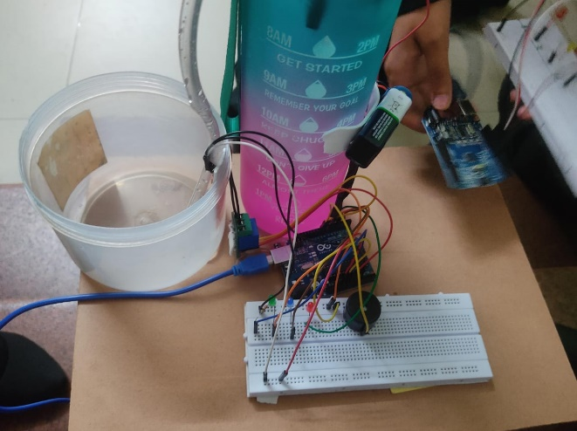 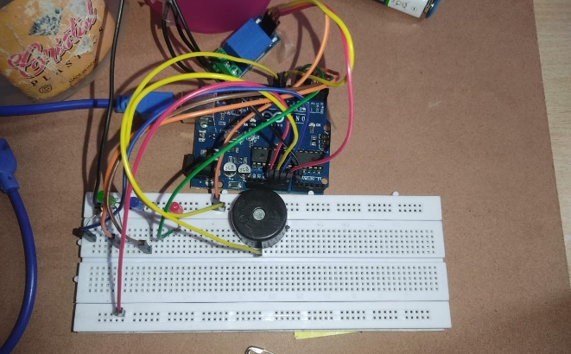

**COMPONENTS**

1.Arduino uno: Arduino Uno is a popular open-source microcontroller board, featuring an Atmega328P chip. With 14 digital I/O pins, 6 analog inputs, and USB connectivity, it's widely used for diverse projects. Easy to program using the Arduino IDE, Uno is favoured for its versatility, making it a go-to choice for makers and enthusiasts. 2.Water level sensor module:The water level sensor module is a compact device that detects water levels in tanks or reservoirs. Utilizing sensors, it provides accurate readings and is often compatible with microcontrollers like Arduino. Widely used in automatic water level indicator systems, it facilitates efficient water management and prevents overflows. 3.LED (Light emitting diode):Light Emitting Diodes (LEDs) are semiconductor devices that emit light when an electric current passes through. Energy-efficient and versatile, LEDs find widespread use in lighting, displays, and indicators. Their small size, low power consumption, and long lifespan make them a preferred choice for various applications in electronics and illumination. 4.Buzzer:A buzzer is an acoustic signalling device that produces a buzzing or beeping sound when an electric current passes through it. Commonly used in alarms, electronic gadgets, and notification systems, buzzers serve to alert or indicate events. They come in various sizes and types, providing audible signals in diverse applications. 5.Breadboard:A breadboard is a crucial tool in electronics for prototyping circuits without soldering. It consists of a grid of interconnected holes, allowing components to be easily inserted and connected. Used for testing and designing circuits, the breadboard facilitates experimentation and rapid development before transferring the circuit to a more permanent setup. 6.Connecting Wires:Connecting wires play a vital role in electronics, linking components on a circuit. These conductive pathways enable the flow of electric current, ensuring proper functionality. Various types, such as jumper wires or ribbon cables, facilitate flexible connections on breadboards and PCBs, crucial for establishing electrical continuity in electronic systems. 7.Motor:A motor is an electromechanical device that converts electrical energy into mechanical motion. Common types include DC motors and AC motors. Essential in countless applications, from appliances to industrial machinery, motors power diverse systems. They consist of coils, magnets, and a rotor, providing efficient and controlled rotational movement. 8.Resistor (220 ohm):A resistor is an electronic component that limits the flow of electric current in a circuit. It is characterized by its resistance, measured in ohms, and is represented by color-coded bands. Resistors are crucial for controlling voltage, current, and protecting components, contributing to the stability and functionality of electronic systems. 9.Battery:A battery is a portable energy storage device that converts chemical energy into electrical energy. Comprising one or more cells, batteries power various devices, from small electronics to electric vehicles. Common types include alkaline, lithium-ion, and rechargeable batteries, providing a reliable and mobile source of electrical power for diverse applications. 10.Relay module:A relay module is an electrical switch that uses an electromagnet to control the opening or closing of circuits. It provides isolation between low-voltage control signals, like those from microcontrollers, and high-voltage loads, such as motors or lights. Commonly used in automation and IoT projects, relay modules enable remote control of devices.

**IV.WORKFLOW**

The working process of a water level indicator involves the following steps:

Breadboard Setup: Connect the Arduino to the breadboard and power it with the battery. Attach the water level sensor to the breadboard, ensuring proper power and ground connections. Connect the relay module to the Arduino to control the motor and alarm.

Sensor Calibration: Calibrate the water level sensor by setting it to the highest and lowest points in the tank, establishing the measurement range.

Wiring the Relay: Connect the relay module to the Arduino, ensuring appropriate connections with the necessary resistor to protect the Arduino from back electromotive force when the relay switches. Motor Connection: Connect the motor to the relay module, enabling the Arduino to control the motor based on the water level.

Integration: Connect the alarm to the relay module, allowing the Arduino to trigger the alarm when the water level reaches a critical point.

Programming the Arduino: Write a program using the Arduino IDE that reads the water level sensor data. Implement logic to control the relay, activating the motor and alarm when the water level reaches predefined thresholds.

Indicator Setup: Connect LEDs or an LCD display to visually represent the water level status, enhancing user awareness. RED (indicating extremely low level)Blue (indicating half water level)Green (indicating full water level)Continuous Monitoring: The Arduino continuously monitors the water level through the sensor data, adjusting the motor, activating the alarm, and updating the indicators as needed.

User Alert and Action: When the water level exceeds or falls below critical levels, the alarm alerts users, and the motor may be activated to prevent overflow or ensure an adequate water supply. This comprehensive setup provides an automatic water level indicator with active control mechanisms, including a motor and alarm system. The relay is a key component, allowing the Arduino to manage higher-power devices and ensuring efficient water management while also notifying users of critical water levels through the alarm.

**CODING**

#include<SoftwareSerial.h>SoftwareSerial B(10,11);int level;const int analog_0=0;int l1=6;int l2=2;int l3=4;int l4=9; void setup() { // put your setup code here, to run once: Serial.begin(9600); pinMode(l1,OUTPUT); pinMode(l2,OUTPUT); pinMode(l3,OUTPUT); pinMode(l4,OUTPUT); pinMode(8,OUTPUT);}void loop() { // put your main code here, to run repeatedly:level=analogRead(analog_0);Serial.println(level);B.print(";");if(level<360){ digitalWrite(l1, HIGH); digitalWrite(l2, LOW); digitalWrite(l3, LOW); digitalWrite(l4, LOW); digitalWrite(8,LOW); }else if(level>355&&level<529) { digitalWrite(l1, LOW); digitalWrite(l2, HIGH); digitalWrite(l3, LOW); digitalWrite(l4, LOW); digitalWrite(8,LOW); }else if(level>563) { digitalWrite(l1, LOW); digitalWrite(l2, LOW); digitalWrite(l3, HIGH); digitalWrite(l4, HIGH); digitalWrite(8,HIGH); }}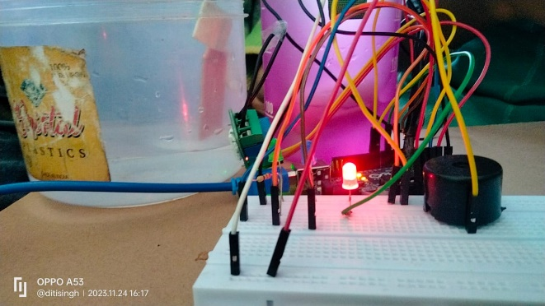**V. RESULT**

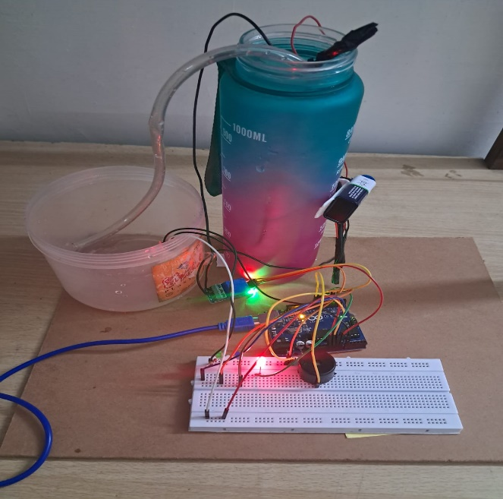

The automatic water level indicator, employing Arduino, a relay, motor, buzzer, and a breadboard, offers a straightforward yet effective solution for water management. The Arduino microcontroller processes data from an ultrasonic sensor, determining the water level in a tank or reservoir. Connected to the Arduino, the relay controls a DC motor functioning as a pump. When the water level falls below a user-defined threshold, the relay activates the motor to replenish the water. Conversely, if the water level surpasses the set limit, a buzzer connected to the Arduino emits an alert, signalling potential overflow.

The circuit is designed to indicate three levels of water stored in the tank: low but not empty, half and full but not overflowing. When there is no water in the tank, all the LEDs are off as an indication that the tank is completely empty. When water level increases and touches the sensor, the Red LED will glow indicating that there is water within the tank. As the water level continues to rise and reaches half the tank, Blue LED will glow. When the water in the tank rises to full the green LED will glow an alarm is made by the buzzer as an indication that the tank is full and the motor is off.

This compact system enhances water efficiency by automating the water level maintenance process. The use of easily accessible components like Arduino and a breadboard makes it an accessible project for hobbyists and students. The implementation not only provides a practical water management solution but also fosters learning in electronics and programming. Overall, this automated water level indicator showcases the practical application of technology in addressing everyday challenges related to water conservation and resource optimization.

**VI. CONCLUSION**

In conclusion, the Automatic Water Level Indicator emerges as a pivotal technological solution for effective water resource management. Its significance lies in its ability to mitigate the risks of water wastage, potential damage, and inefficient usage in various settings. By leveraging sensors, microcontrollers, and alarm systems, the indicator offers real-time monitoring, preventing overflows and ensuring a controlled water supply. The advantages of convenience, customization, and sustainability position it as an invaluable tool for residential, industrial, and agricultural applications. Despite considerations such as initial costs and maintenance, the long-term benefits in terms of water conservation, cost-effectiveness, and enhanced safety make the investment worthwhile. The system not only aligns with the growing global focus on environmental sustainability but also serves as an educational platform for understanding electronics, sensors, and automation. As technology advances, the Automatic Water Level Indicator continues to evolve, with potential improvements in sensor accuracy, system reliability, and user-friendliness. Embracing this technology not only addresses immediate water management water scarcity concerns worldwide.With the help of this project, we aim to save electricity as well as water. It is very important to save the natural resources. When the water in bucket /tank is reaches at a particular level we don’t realize that the tank is overflowing. This leads to more water as well as energy consumption. People too get engaged in that and stop doing other work until the tank is full which can cause a lot of unnecessary time consumption. So to overcome this situation this project can sense and indicate the water level in the tank when it reaches at a particular level and then the pump/tap turns on/off which will save water and electricity. Therefore, the water level monitoring and controller using Arduino project can prove very helpful in minimizing the use of man power. Its application is not only limited to house hold but can also be used in the industrial and agricultural sector challenges but also contributes to a broader commitment to responsible resource utilization and environmental stewardship in the face of increasing water scarcity concerns worldwide.

**VII. REFERENCES**

# [1] International Journal Of Research Construction Of Digital Water Level Indicator And Automatic Pump Controlling System, Md.Sourove Akther Momin, Pratik Roy, Vol-3, Issue-12, August 2016

# [2] An Automatic Water Level Indicator, Aranyak Roy, Oyndrila Roy, Vol-2, Issue-6, March-2016

# [3] A Review Of An Automatic Water Level Indicator, Abubakar Sadiq Muhammad, Vol-2, Issue-3,16-May-2020